PROJECT ZEPHYRAQUU EnGInEERInG NOTEBOOk
PROTOTypE V0.1 – MEchanIcal LayOuT PROTOTypE aEmBly

Objective-001:
The objective of today's session was to begin the first full-scale mechanical layout of the hoverboard prototype. The goal was to establish the board dimensions, determine the center of gravity, position all eight propulsion units, and verify that sufficient propeller clearance exists before transferring the design to plywood.

DG-001 (Design Goals 001):
- Eight distributed lift motors
- Symmetric layout
- Centered battery
- Compact electronics
- Modular design
- Easy transfer to plywood prototype

Component Status
Cardboard prototype ✅
8× EMAX ECO II motors ✅
4-inch propellers ✅
6000 mAh 4S battery ✅
2× SpeedyBee F405 stacks ✅
FlySky transmitter ✅

DD-001 (Design Decisions 001):
- A prototype board measuring approximately 22 in × 12 in from the ≈ 2ft x 4ft cardboard board from a TV box was selected to provide adequate spacing for eight propulsion units while maintaining a compact footprint.
- Centerlines were drawn across the board to determine the geometric center/center of gravity. The approximate center of gravity was verified by balancing the prototype on a single finger positioned at the intersection of the centerlines.. The battery was positioned near this location since it is the heaviest component.
- The motors were arranged symmetrically to balance thrust. Fig. 1 shows the motors where the left most side is the front while the rightmost is the back. The top row of the motors are even (M2, M4, M6, M8) and the bottom row are the odd numbered motors (M1, M3, M5, M7).
- Using 4-inch propellers, the layout provides sufficient clearance between adjacent propellers. No overlap was observed during manual inspection as observed from Fig. 1.
Figure 1. Placement of all basic components before integration
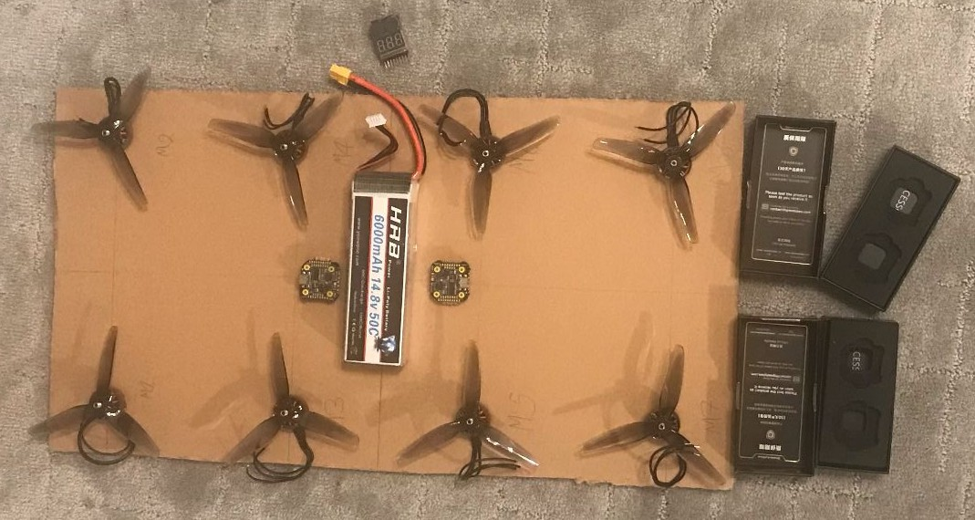

ECE-001 (Engineering Challenges Encountered 001):
  - Drew centerlines to maintain symmetry and center of gravity.
  - Redrew centerlines to ensure center of gravity was correct.

